Hkkjr ekSle foKku foHkkx |  | India Meteorological Department
Hkkjr ekSle lkjka’k |  | DAILY WEATHER SUMMARY
Thursday, 05th May 2022 (15th Vaisakha 1944 Saka)
Summary of observations recorded at 0830 hours IST: The western disturbance as a cyclonic circulation over north Pakistan and neighbourhood lay as a trough in mid and upper tropospheric westerlies with its axis at 5.8 km above m. s. l. roughly along Long. 75°E to the north of Lat. 32°N. A fresh feeble western disturbance as a trough in middle tropospheric westerlies with its axis at 5.8 km above m. s. l. ran roughly along Long. 62°E to the north of Lat. 30°N. Above two systems are likely to move east-northeastward. A cyclonic circulation lay over northwest Madhya Pradesh and neighbourhood which extended upto 0.9 km above m. s. l. The trough / wind discontinuity at 0.9 km above m. s. l. from Vidarbha to south Tamil Nadu ran from the cyclonic circulation over northwest Madhya Pradesh to Comorin area across Vidarbha, Telangana, Rayalaseema and interior Tamil Nadu at 0.9 km above m. s. l. The trough at 0.9 km above m.s.l from Punjab to Manipur ran from the cyclonic circulation over northwest Madhya Pradesh to Meghalaya across Chhattisgarh, Jharkhand and West Bengal at 0.9 km above m. s. l. A trough ran roughly along Long.90°E to the north of Lat.20°N between 3.1 km and 3.6 km above mean sea level. The cyclonic circulation over south Andaman sea and neighbourhood which extended upto mid tropospheric levels persists. Under its influence, a low pressure area is likely to form over the same region around 06th May. It is very likely to move northwestward and intensify gradually into a depression during subsequent 48 hours. The cyclonic circulation over southeast Uttar Pradesh and neighbourhood became less marked.
Day temperatures were above normal (1.6°C to 3.0°C) at many places over coastal Karnataka; at a few places over Haryana, Chandigarh, Delhi, Saurashtra, Kutch, east Uttar Pradesh, Konkan, Goa, Kerala, Mahe, Tamil Nadu, Puducherry and Karaikal; at isolated places over Odisha. They were markedly below normal (-5.1°C or less) at many places over Jammu- Kashmir and Ladakh, Gilgit, Baltistan, Muzaffarabad; appreciably below normal (-3.1°C to -5.0°C) at
a few paces over Himachal Pradesh and Punjab; below Normal (-1.6°C to -3.0°C) at most places over Bihar, Gangetic West Bengal, Nagaland, Manipur, Mizoram, Tripura and Telangana; at many places over Chhattisgarh, coastal Andhra Pradesh, Yanam, Andaman and Nicobar Islands; at a few places over east Uttar Pradesh, Sub Himalayan West Bengal, Sikkim and Rayalaseema; at isolated places over east Madhya Pradesh and near normal over rest parts of the country. The highest maximum temperature of 44.0°C was reported at Ahmednagar (Madhya Maharashtra).
Thunderstorm observed (from 0830 hrs IST of yesterday to 0830 hours IST of today): at isolated places over Jammu-Kashmir and Ladakh, Chhattisgarh, Punjab, Uttarakhand, Haryana, Chandigarh, Delhi, Uttar Pradesh, Assam, Meghalaya, Tripura, Jharkhand, Karnataka, Rayalaseema, Tamil Nadu, Lakshadweep and Kerala.
Hailstorm reported at isolated places over Punjab, Haryana, Delhi, west Uttar Pradesh and Marathwada.
Thundersquall reported at isolated places over Uttarakhand, west Uttar Pradesh; with lightning and gusty wind; at isolated places over Vidarbha, Chhattisgarh, coastal Andhra Pradesh, Yanam and Telangana

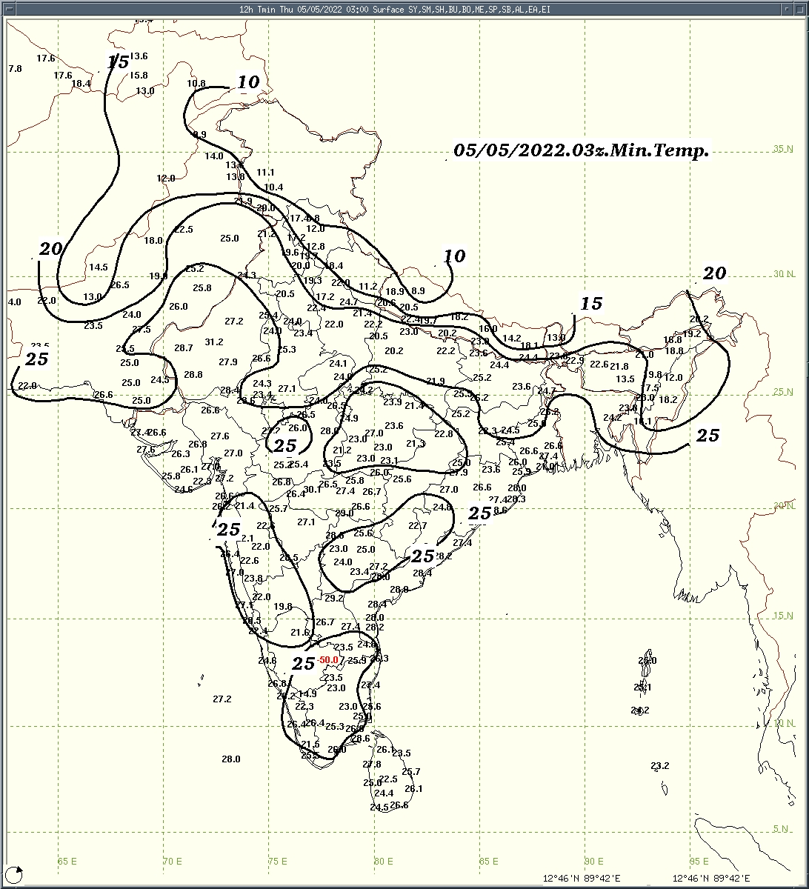 | 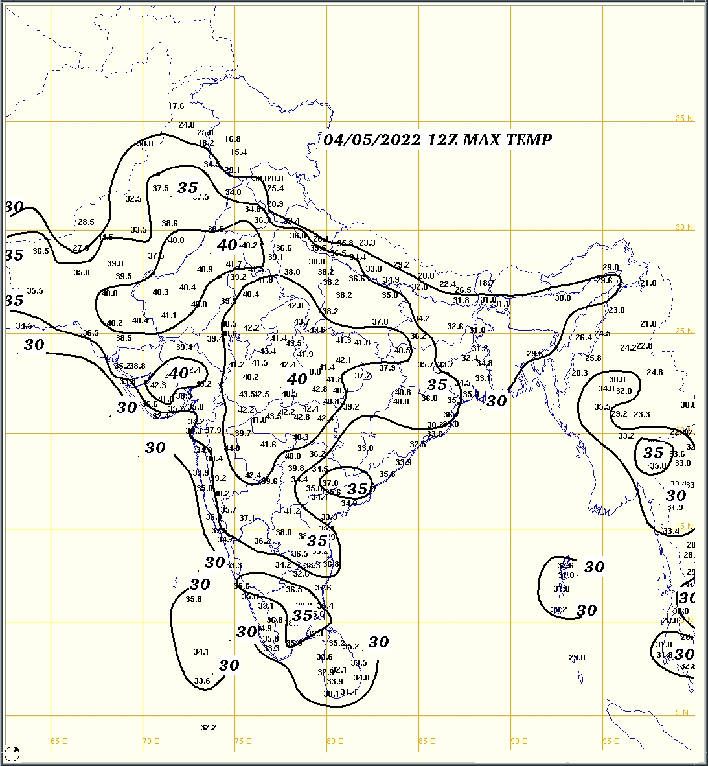 | 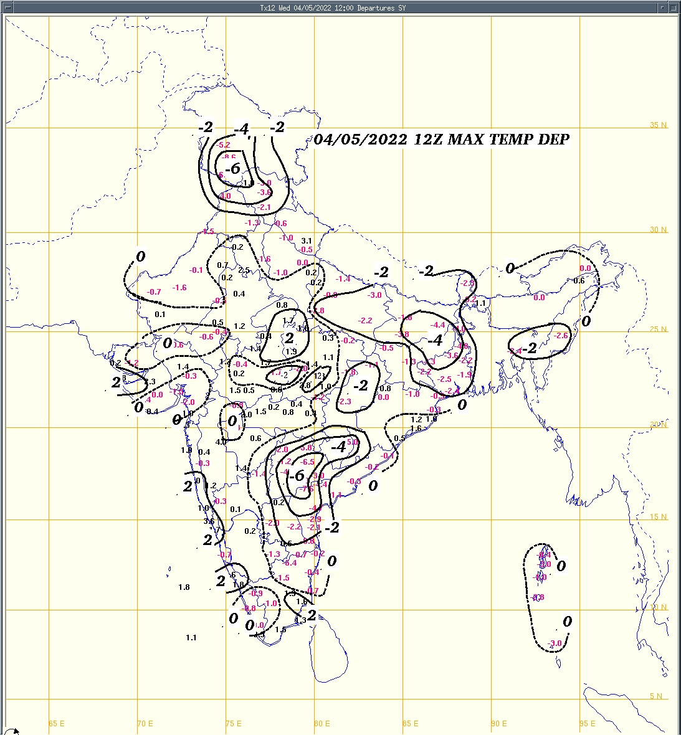
Fig.1a: Minimum temperature (⁰C) | Fig.2a: Maximum temperature (⁰C) | Fig.2b: Maximum temperature departure(⁰C)
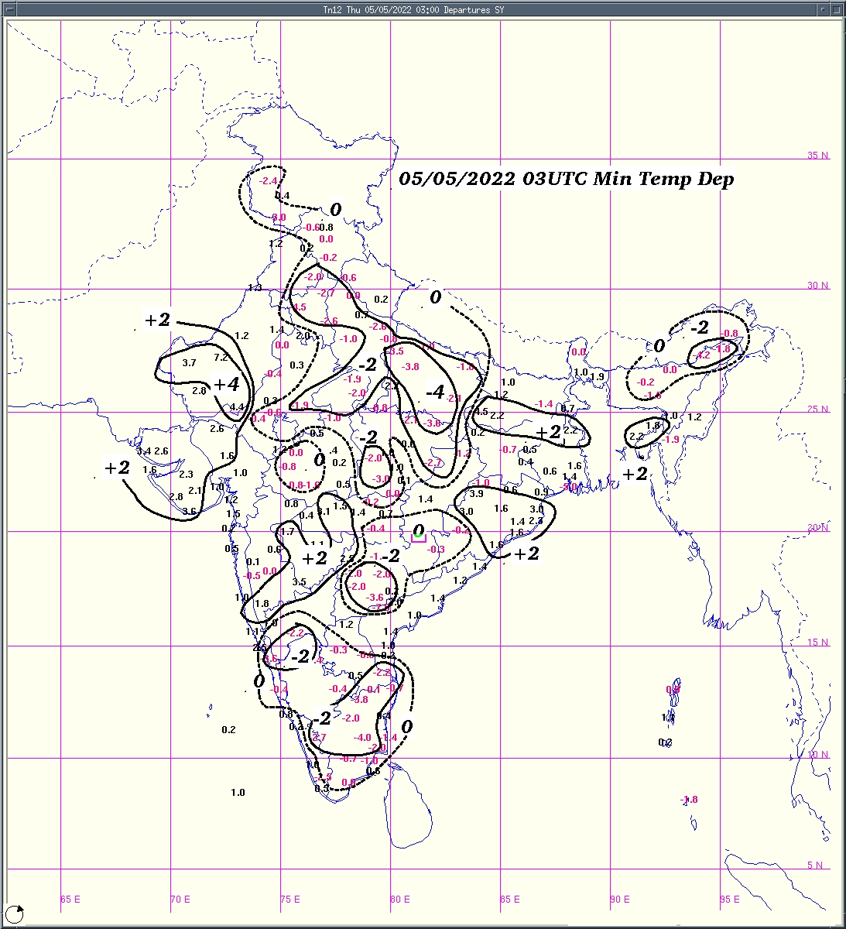  Fig.1b:Minimum temperature departure (⁰C) | 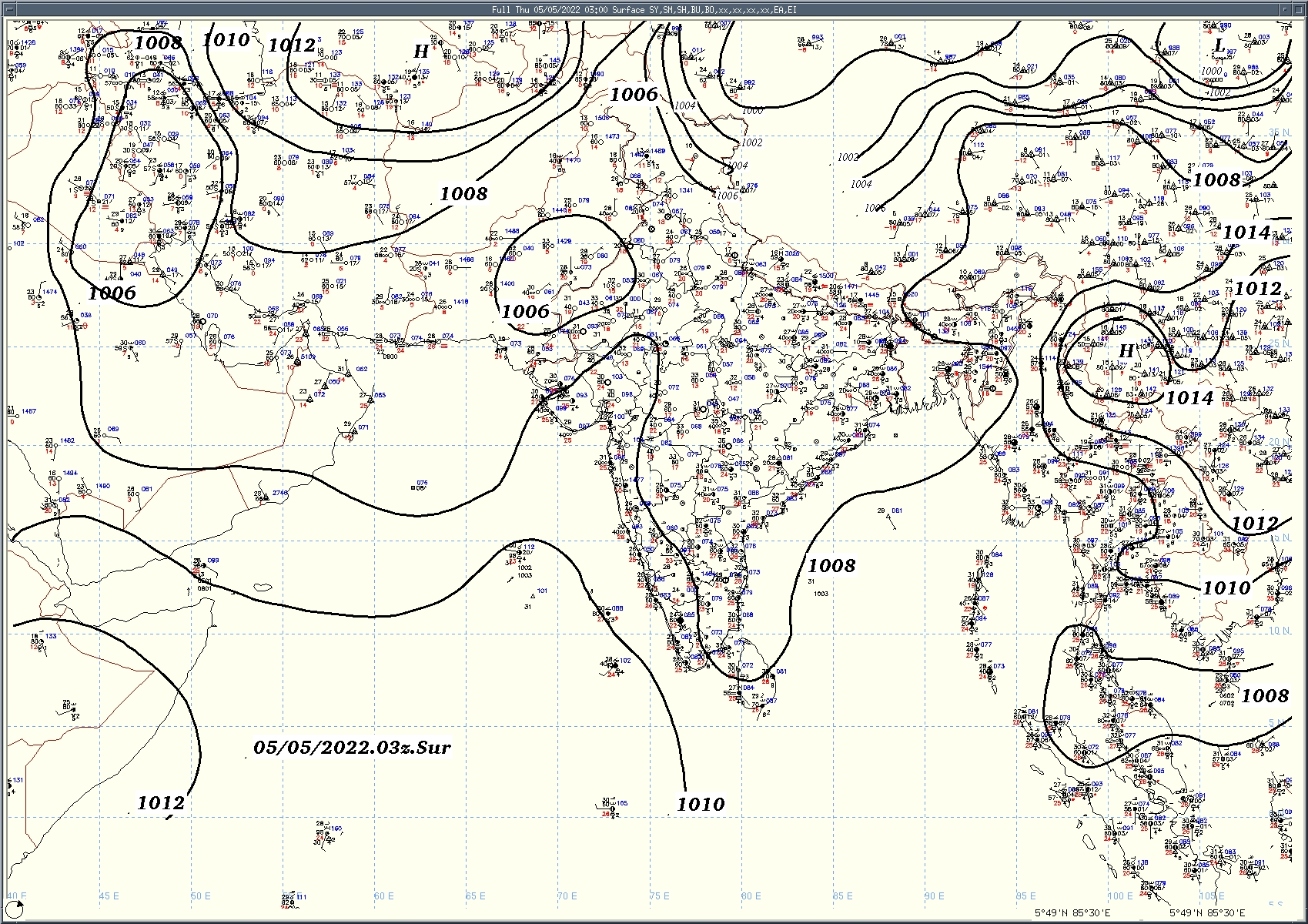  Fig.3: Analysed surface chart based on 03z observation
Dr. Anupam Kashyapi,
Scientist 'F'
CR & S Office, Pune  Issued at 1245 hrs. IST |  | Weather Forecasting Division

Indian Regions | Table 1. Realised rainfall (chief amount in cm during past 24 hrs)
East | many places: Nagaland-Manipur-Mizoram-Tripura  a few places: Arunachal Pradesh and Sub-Himalayan West Bengal & Sikkim  isolated places: Assam & Meghalaya, Odisha, Jharkhand and Bihar  dry weather: Gangetic West Bengal  Gangtok 6.1, Tadang 3.7, Ahirwalia 3.0, Padmapur & Darauli 2.9 each, Panposh 2.6, Rongo 2.3, Kanchanpur 2.1, Kvk dhalai 2.0, A p ghat & Jowai 1.3 each, Bano simdega kvk AWS 1.2, Agartala aero & Palkot 1.0 each, Basar & Shillong c.s.o. 0.9 each, Seppa 0.8, Chapra 0.6, Bomdila 0.1.
North | most places: Jammu-Kashmir and Ladakh  many places: Haryana  a few places: Uttar Pradesh, Uttarakhand, Punjab and Himachal Pradesh  dry weather: Rajasthan  Jhansa irr 6.0, Muzaffarnagar 5.1, Fursatganj 4.5, Muzaffarnagar teh 4.1, Patiala 3.9, Bikapur & Ismailabad 3.5 each, Bhadson irr 3.4, Salempur & Karnal 3.1 each, Sirhind 3.0, Gulmarg 2.9 each, Garud 2.2, Etah & Kasauli 2.1 each, Kotdwar 2.0, Pachhad & Batote 1.7 each, Munsiyari 1.6, Dharmsala 1.5.
Central | isolated places: Madhya Pradesh and Vidarbha, Chhattisgarh  Deobhog 3.5, Bhaiyathan 3.3, Sidhi (gopadbanas) 3.2, Bilhari & Jashpurnagar 2.2 each, Sirmaur 0.8, Bhind- 0.7.
Peninsula | many places: coastal and south interior Karnataka+ and Kerala  a few places: Tamil Nadu+ and north interior Karnataka+  isolated places: Marathwada ,coastal Andhra Pradesh, Telangana and Rayalaseema  dry weather: Gujarat Region, Saurashtra & Kutch, Konkan & Goa, Madhya Maharashtra and  Palavidithi 9.3, Kamatchipuram 8.5, Manki 7.5, T narasipur 7.2, Belur 7.1, Haveri apmc 6.7, Honavar obsy 6.2, Ranebennur (hos) 5.8, Meenkara ARG 5.1, Macherla 4.4, Vadakkancherry 4.2, Santhipuram & Hassan 4.1 each, Kuppam & Punalur 4.0 each, Tirupati aero 3.9, Podili 3.6, Haveri e.e.o. 3.5, Sulya 3.4, Banswada 3.0, Sulur 2.1, Jagtial 1.7, Jangamaheswarapuram 1.5, Hyderabad a.p. 0.3.
Islands | many places: Andaman & Nicobar  dry weather: Lakshadweep  Carnicobar IAF 3.0, Nancowary 2.7, Hut bay 1.7.
Table 2. Forecast / warnings (distribution of rain / thundershowers) for 5 days (valid from time of origin upto 0830 hrs IST of next day)
Sr. No. | Sub-division Name | Day 1 | Day 2 | Day 3 | Day 4 | Day 5 | Sr. No. | Sub-division Name | Day 1 | Day 2 | Day 3 | Day 4 | Day 5
 |  | 05 May | 06 May | 07 May | 08 May | 09 May |  |  | 05 May | 06 May | 07 May | 08 May | 09 May
1 | Andaman Nicobar Islands | W+ | W++ | W ++ | W+ | F | 19 | west Madhya Pradesh | D | D | D | D+ | D+
2 | Arunachal Pradesh | I | I | S | S | F | 20 | east Madhya Pradesh | I | D | D | D+ | D+
3 | Assam-Meghalaya | S | S  | S | S | F | 21 | Gujarat Region | D | D | D | D | D
4 | Nagaland-Manipur-Mizoram-Tripura | S | S  | S | F | F | 22 | Saurashtra and Kutch | D | D | D | D | D
5 | Sub Himalayan West Bengal/Sikkim | S | F | F | S | S | 23 | Konkan and Goa | D | D | D | D | D
6 | Gangetic West Bengal | S | S  | I | I | I | 24 | Madhya Maharashtra | D+ | D | D | D | D
7 | Odisha | S | S | I  | I | I | 25 | Marathwada | I | D | D | D | D
8 | Jharkhand | S | I | I | I | I | 26 | Vidarbha | I | D | D | D+ | D+
9 | Bihar | S | I | I | S | S | 27 | Chhattisgarh | I | I | I  | I | I
10 | east Uttar Pradesh | I | I | I | I | I | 28 | coastal Andhra Pradesh and Yanam | I | I | I  | I | I
11 | west Uttar Pradesh | I | D | D | D+ | D+ | 29 | Telangana | I | I  | I  | I | I
12 | Uttarakhand | I | I | I | D | D | 30 | Rayalaseema | I | I | I  | I | I
13 | Haryana, Chandigarh and Delhi | I | D | D | D+ | D+ | 31 | Tamil Nadu, Puducherry and Karaikal | S+ | S  | S | S | I
14 | Punjab | I | D | D | D | D | 32 | coastal Karnataka | F | I | I | I | I
15 | Himachal Pradesh | I | I | I | D | D | 33 | north interior Karnataka | I | I | I | I | I
16 | Jammu-Kashmir and Ladakh | S | I | I | D | D | 34 | south interior Karnataka | F+ | S  | S | S | S
17 | west Rajasthan | I  | D | D+ | D+ | D+ | 35 | Kerala and Mahe | F+ | F | F | S | S
18 | east Rajasthan | D | D | D+ | D+ | D+ | 36 | Lakshadweep | F | S | S | S | S

Legends: D = Dry I = Isolated S = Scattered F = Fairly widespread W = Widespread #= heavy to very heavy rain at a few places with extreamly heavy rain at isolated places +++= heavy rain at a few places with very heavy rain at isolated places ++ = heavy to very heavy rainfall + = heavy rain ●/* = rain or snow ♦ = very light rain ≡ =fog = thunderstorm with lightning =Squall / Gusty wind / strong wind / gale wind -=cold wave/cold day +-= heat wave =Duststorm SS=ground frost = Hail
Fig. 4: Districtwise warnings for five days for Maharashtra State

Pune, Lohegaon and Pashan observations at 0830 hrs. IST of Today
 | Temperature (°C) |  |  |  |  |  |  |  |  |  |  |  |  |  | Humidity (%) |  |  |  |  |  |  | Rainfall (mm)
 | Max.  past  24 hrs |  |  |  | Dep.  from  normal |  |  | Min.  past  24 hrs. |  | Dep.  from  normal |  | Dry  Bulb |  |  | At 0830 hrs. IST |  | Dep.  From  normal |  | At 1730  hrs. IST of y’day |  | Dep.  from  normal | Past  24 hrs. | Since  1st March | Dep.  from  normal
PNE | 38.4 |  |  |  | 0.4 |  |  | 22.1 |  | 0.6 |  | 27.2 |  |  | 55 |  | 1 |  | 17 |  | -13 | 0.0 | 1.2 | -17.2
PSN | 39.2 |  |  |  | - |  |  | 21.2 |  | - |  | 25.4 |  |  | 68 |  | - |  | 18 |  | - | 0.0 | 0.8 | -
LHG | 39.3 |  |  |  | 1.3 |  |  | 23.6 |  | 2.6 |  | 27.7 |  |  | 66 |  | 13 |  | 13 |  | -14 | 0.0 | 0.8 | -21.5
Local (Pune and neighbourhood) forecast)
Max. / Min. Temperature (°C) |  |  |  |  |  |  |  |  |  |  |  |  |  | Weather
Date | Pune |  | Pashan |  |  | Lohegaon |  |  | Chinchwad |  | Lavale |  | Magarpatta
05/05 | 39 / 22.1* |  | 39 / 21.2* |  |  | 40 / 23.6* |  |  | 40 / 24.2* |  | 40 / 22.0* |  | 40 / 25.1* | Mainly clear sky becoming partly cloudy sky towards afternoon / evening.
06/05 | 39 / 22 |  | 40 / 21 |  |  | 40 / 23 |  |  | 41 / 24 |  | 40 / 22 |  | 40 / 25 | Mainly clear sky .
07/05 | 40 / 21 |  | 40 / 21 |  |  | 40 / 22 |  |  | 41 / 23 |  | 41 / 22 |  | 40 / 24 | Mainly clear sky .
08/05 | 39 / 22 |  | 39 / 21 |  |  | 40 / 22 |  |  | 41 / 23 |  | 40 / 22 |  | 40 / 24 | Mainly clear sky.
09/05 | 39 / 22 |  | 39 / 22 |  |  | 39 / 23 |  |  | 40 / 24 |  | 40 / 23 |  | 39 / 25 | Mainly clear sky becoming partly cloudy sky towards afternoon / evening.
10/05 | 38 / 23 |  | 38 / 22 |  |  | 39 / 24 |  |  | 39 / 25 |  | 39 / 24 |  | 39 / 25 | Partly cloudy sky.
11/05 | 37 / 23 |  | 38 / 22 |  |  | 38 / 24 |  |  | 39 / 25 |  | 38 / 24 |  | 38 / 26 | Partly cloudy sky.
Mumbai (Colaba) |  |  |  |  |  |  |  |  |  |  |  |  |  |  |  | Nagpur (AP)
Date |  | Tmax °C |  | Tmin °C |  |  | Weather |  |  |  |  |  |  |  |  | Tmax °C |  | Tmin °C |  | Weather
05/05 |  | 34 |  | 26 |  |  | Mainly clear sky becoming partly cloudy towards afternoon or evening. |  |  |  |  |  |  |  |  | 43 |  | 26 |  | Partly cloudy sky.
06/05 |  | 35 |  | 26 |  |  | Mainly clear sky. |  |  |  |  |  |  |  |  | 44 |  | 28 |  | Partly cloudy sky.
07/05 |  | 35 |  | 27 |  |  | Mainly clear sky. |  |  |  |  |  |  |  |  | 44 |  | 29 |  | Partly cloudy sky.
08/05 |  | 34 |  | 27 |  |  | Mainly clear sky becoming partly cloudy towards afternoon or evening. |  |  |  |  |  |  |  |  | 44 |  | 30 |  | Partly cloudy sky.
09/05 |  | 34 |  | 27 |  |  | Mainly clear sky becoming partly cloudy towards afternoon or evening. |  |  |  |  |  |  |  |  | 44 |  | 30 |  | Partly cloudy sky.
10/05 |  | 33 |  | 27 |  |  | Partly cloudy sky. |  |  |  |  |  |  |  |  | 45 |  | 31 |  | Partly cloudy sky.
11/05 |  | 34 |  | 27 |  |  | Mainly clear sky. |  |  |  |  |  |  |  |  | 45 |  | 31 |  | Partly cloudy sky.

Widespread (W) | 76 - 100 |  |  |  |  | - Rainfall | Very light rain | trace to 2.4
Fairly widespread (F) | 51 - 75 |  |  |  |  |  | Light rain | 2.5 to 15.5
Scattered (S) | 26 - 50 |  |  |  |  |  | Moderate rain | 15.6 to 64.4
Isolated (I) | 1 - 25 |  |  |  |  |  | Heavy rain | 64.5 to 115.5
Dry (D) | No Rain |  |  |  |  |  | Very heavy rain | 115.6 to 204.4
Probability Terms in %: |  |  |  |  |  |  | Extremely heavy rain | ≥ 204.5
unlikely | < 25 |  |  |  |  | - Snowfall | Heavy snow | 6.5 to 11.5 cms water equivalent of rain
likely | between 25, 50 |  |  |  |  |  | Very heavy snow | 11.6 to 20.4 cms water equivalent of rain
very likely | between 51, 75
most likely | >75

